Foreign Language Analysis products by Encyclopædia Britannica

Extracting high-level intelligence information from foreign language sources has generated significant interest in recent years. Two important foreign languages in respect to intelligence information are Arabic and Persian (Farsi), languages that are structurally very different from English (this is radically so in Arabic), and that use non-Latin script. Encyclopaedia Britannica’s Natural Language Technologies Division has developed unique technology for analyzing foreign languages, with an emphasis on non-Latin script languages.

The challenge of processing foreign language data: is Machine Translation appropriate?

The huge quantities of acquired textual data that require monitoring and exploitation, and the limited resource of human translators with a high-level knowledge of relevant foreign languages (and the required security clearance) make human translation of all available foreign language texts into English an inadequate solution for the task at hand. A common alternative that comes to mind is to run all incoming information through Machine Translation (MT) to translate all information into English, and then process it in English. For this approach to be feasible, MT must provide highly accurate, near-human quality translation that would be both intelligible and contain a correct translation of all source language threat content, proper names, and place names, enabling proper threat detection, monitoring, and information retrieval over the source data. However, in spite of advances in computer technology, high quality MT has remained an unsolved problem, and does not yet provide results accurate enough to replace the original foreign language texts.
Furthermore, MT's goal is to provide textual translation, and not a tagged, analyzed representation of the original text; consequently, it is not suitable for automatic analysis of foreign language, since much entity information, of the very type that is commonly targeted by monitoring systems and search engine queries, is lost going from the original text to the MT output text in English, due to the inherent ambiguity of these foreign languages. Interestingly in this regard, most Arabic proper names can also be interpreted as nouns or adjectives, and are therefore often mistranslated. Furthermore, the English output may be ambiguous in itself; for example, several different Arabic words can be translated to the English word “tank”. By only processing the English translation, the true category of the word, which was extractable in the Arabic source document (e.g. a military vehicle, or by contrast, a container), is lost and cannot be reproduced.
MT also often suffers from misinterpretation of the source grammar and word order, incorrect substitution or alignment (in the case of statistical MT); and often errs in morphological disambiguation of source strings (that mean different things in different contexts, especially in highly ambiguous languages such as Arabic). Finally, since MT tries to parse whole sentences and generate equivalent sentences, the complex statistical and/or syntactical mechanisms it employs are resource-intensive processes that may often result in a bottleneck in any automated intelligence analysis system.

Encyclopædia Britannica's approach: Direct automatic processing of data in source languages, using cross-language tools
Encyclopædia Britannica's cross language Morphological Analysis (BMA) and cross language Entity extraction (EntX) allow access in English to original Arabic and Farsi source language data. BMA analyzes each word or phrase in the source language, disambiguating and normalizing it to a common form, and produces a common, disambiguated form both in the source language and English. EntX is a cross-language entity extraction solution that extracts named entities from source language texts, determining the category and correct delimitation of each entity, and provides these entities both in their original language and in English, properly categorized. Entities include proper names, place names, and other categories including: nationalities, organizations, weapons, chemical substances, currencies, etc.; EntX also support English user-defined categories, to allow taxonomies and ontologies developed in English to be directly applied to the information in the source languages.
BMA and EntX produce highly accurate representations, due to robust foreign language tagged lexical databases and to analysis algorithms developed specifically for morphological analysis of complex languages; these may be automatically processed by existing applications, due to structured English representations of the original document.
BMA and EntX consume foreign language text, and provide an XML document containing the most appropriate equivalent English terms for foreign language words, or, if proper names are encountered, accurate English string representations of the source language names. The XML data contains detailed tagging including: part of speech, semantic category, prepositional prefixes, etc.
A unique disambiguation system employs context analysis to yield the correct analysis per input word, and to identify cases where the input text includes phrases that are not transparently translated on a word by word basis; such phrases are matched as a single entity to appropriate English equivalents.
All inflectional and orthographic variants, including those pertaining to proper names, are normalized to a single form per entity. Note that in Arabic, for example, a word can have thousands of inflections. This is very different from English, where a word can have up to five or six inflections. Therefore normalizing all forms into a single identifiable form is of crucial importance.
Finally, EntX includes a patent-pending user interface, utilizing ETL (Embedded Translation Layer), where the user of the system can actually invoke a layer of English translation for any source language word or phrase by simply placing the mouse over word, while viewing the original foreign language document. This user interface is supplied by the EntX Server, and does not require the installation of any client software.
BMA and EntX offer exceptionally high performance, with accuracy exceeding 95%, and processing over ten thousand words per second on a standard 4 CPU server.
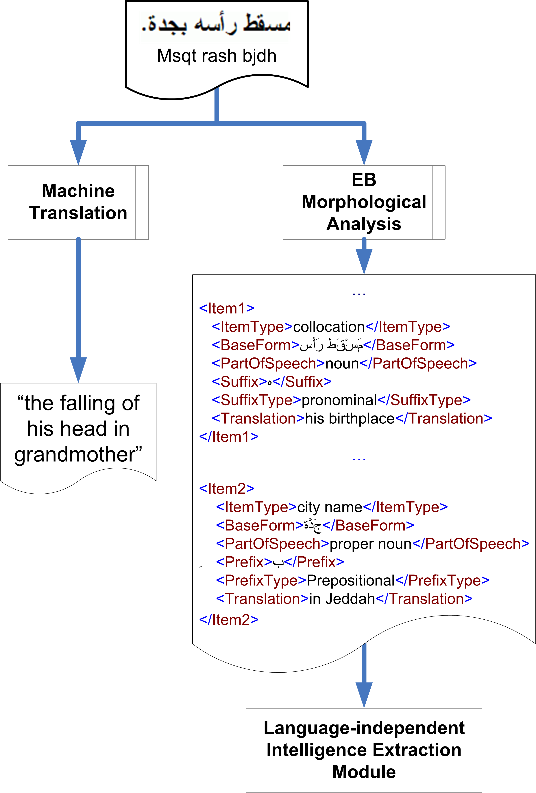

Figure 1:
the analysis provided by Encyclopædia Britannica by employing both BMA and EntX, outputs structured data - not texts - where foreign language is represented as data structures where original source language words are:
(a) disambiguated
(b) normalized
(c) accurately translated into English and
(d) categorized.
This XML structure is most appropriate for indexing, searching, entity extraction, monitoring, automatic categorization, and all automatic processes that need to be carried out on large quantities on foreign language data. By contrast, a textual output of a machine translation system often yields incorrectly interpreted text, with no further information.

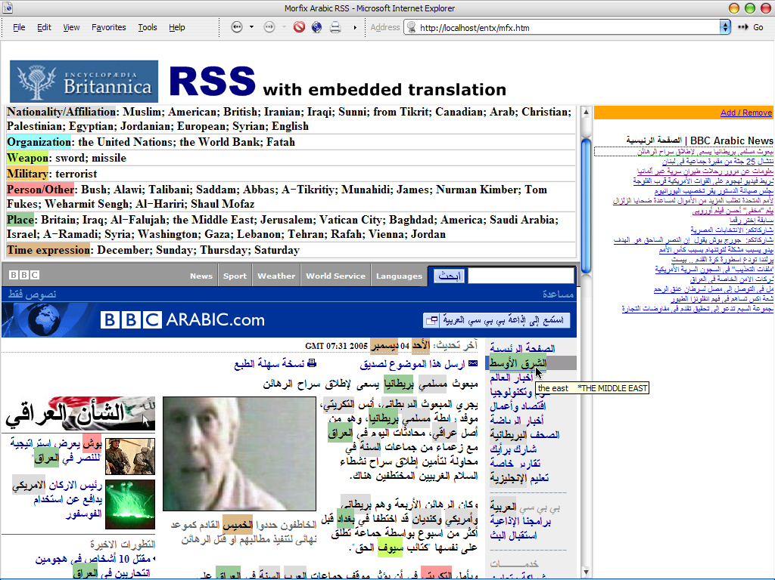

Figure 2: EntX with ETL. An example RSS wrapper for EntX Server as viewed in a standard browser. Note the Cross-language Entity Digest header (including color-coded categorization), the entity extraction in the original Arabic document (color-coded), and the example of Embedded Translation Layer (ETL) for the phrase "The Middle East" appearing as a tool-tip in the right hand column of the displayed web page.

