Adding Full-text Searching to VBA Applications

F. Scott Barker

What is Full-Text Searching?
With all the buzz about XML and internet technologies for this and that, full-text searching, as are many cool technologies, is taking a back seat. However, it is becoming more and more important to people. Full-text searching is the ability to search through large amounts of text data, both off and on the Web.
With regular databases, you can index and search certain types of data, such as numeric, and small text, up to 256 characters. With full text, you can maintain indexes for large and variable length text, such as memo fields. Some full-text search engines allow you to even search other file formats, including:
- Search independent file types such as:
- Text files (*.txt)
- Word files (*.doc, *.rtf)
- Acrobat files (*.pdf)
- Mail files (*.pst)
- XML Files
- Many others

Note: Not all features described here are implemented in all full text search engines. However, the majority of them are available in the dtSearch engine, which will be discussed later in more detail.

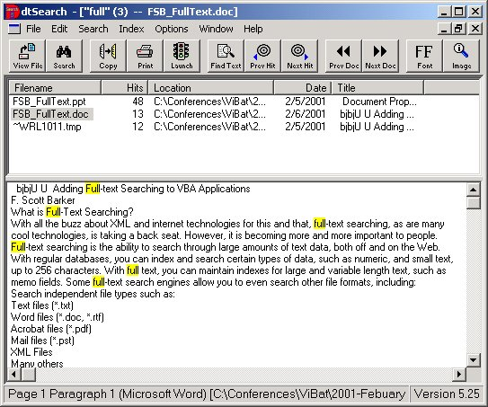
Text engines differ in what they return for results, but some of the common items are number of hits, documents (tables), and lines / paragraphs / records where the results appear.

Where Can Full-Text Searching Be Used?
Full-text searching is useful whenever you need to search a large amount of data, or need to search outside applications.
Some examples of possible applications are:
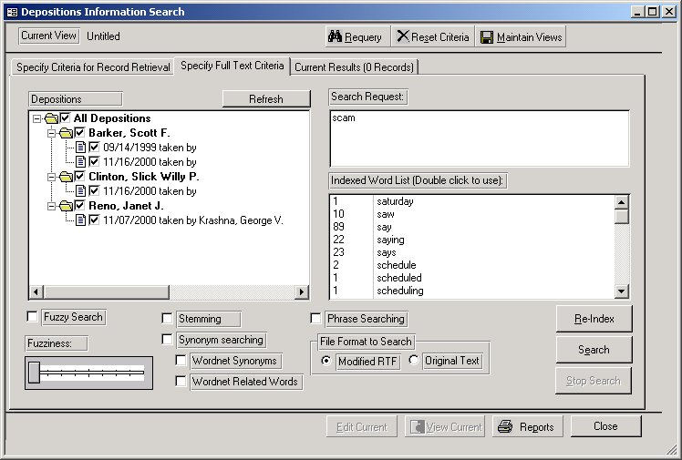
- Library Databases – Used for tracking books or articles, you could use full text searching on titles and even text with the books or articles.
- Lawfirm Case Management Systems – Here you can see depositions being search for the term “scam”.

- Career (Resume) Tracking Systems
- Help Desk Systems
Another nice thing with the major full text search engines is you can access them with most major languages such as C/C++ and Visual Basic.

Full-Text Search Terms
As with most areas in technology there are certain terms that are used to describe various options, or in this case, search parameters. Again, not all search engines support all the search options.
- Indexes – as with database indexes, full text indexes are used to speed up searches. Indexes not only include database fields however, but can include many of the document types supported by the search engine.
- “Fuzzy” Searches – how exact do you want the search. For instance, if you think a word might be misspelled, and you are looking for close matches, a fuzzy search would come up with the word, where a non-fuzzy search would not.
- Phonic – perform a phonetic search for the words.
- Natural Language – the user can enter the search word in a natural sentence, and the engine will pick out the words itself. This is useful for help desks, when users need to enter questions.
- Stemming – Allows the user to enter forms of words, and the engine finds matches that stems from them, such as say the user enters “front”, the engine would return front, fronts, fronting.
- Synonyms – returns synonyms for words.
- Hits (no mafia here) – number of words that match the entered word(s) based on the options chosen.

Two Common Full-Text Search Engines
There are a few main full-text search engines that I have come across. I am going to talk about two of them here: SQL Server 7.0, and dtSearch’s Search Engine.

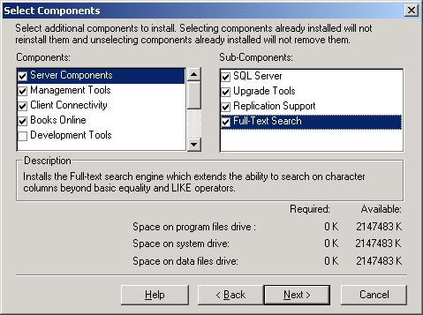
SQL Server 7.0
The full text search engine must be chosen when you install SQL Server 7.0
Once installed full text indexes and search capability can either be access via the interface, or though stored procedures.

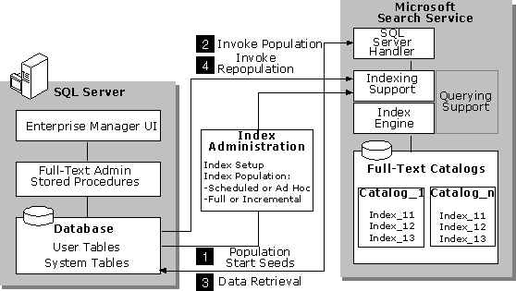
SQL Server 7.0 full text capability is handled by Microsoft Search Service. With it you can search both fields inside the database, or files within the file system.
dtSearch Search Engine
dtSearch (www.dtSearch.com) has a number of tools that make up their product line. I am going to talk strictly about their search engine (version 6.0.)
The search engine does come with a number of demos, and an end user application for maintaining indexes, performing searches, and reporting results. The stand alone application is in fact built over the same engine that developers can purchase to use in their own applications.

Developing with dtSearch’s Search Engine ActiveX API and VBA (or VB)
All the objects and code discussed can be found in vbSearch.vbp on the evaluation disk of dtSearch engine.
The first thing you will need to do to use the dtSearch search engine in your VBA application is to set a reference to dtEngine.dll.
Once you have set a reference, you will have access to the following objects:
- dtEngine - Top Object, when application starts

Maintaining Indexes
- IndexJob - Used for maintaining indexes
Performing Searches
- WordListBuilder - Used for displaying a list of words for searching
- SearchJob - Object used for actual searching
- SearchJobResults - Results for the search performed
- JobErrorInfo - Any errors with the search job are listed here
Reporting Search Results
- SearchReportJob - Formatting for reporting results

In Conclusion
If you find you have a need to be developing using Full Text Search capabilities, then you are ready to jump into a whole new world.

